**Program 8: Reverse the entered string**

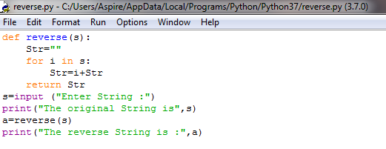

**Output**

